Corner Grocer Program

Ashlynn Borro
Southern New Hampshire University
CS- 210- Programming Languages
Instructor: Trivino, Luis
December 10, 2025

For this project, I created a C++ program that helps the Corner Grocers track how frequently different produce items are purchased throughout the day. The program reads an input file of item names, counts how often each one appears, and gives the grocery store useful output that can help them organize their produce section more efficiently. This project allowed me to apply object-oriented programming, file handling, and maps in a real-world scenario similar to what a junior developer at Chada Tech would do.
I structured my program around a single class called ItemTracker, which contains both public and private sections as required. The private section holds a map<string, int> to store item names and their frequencies. The public section provides methods to load items from a file, write the backup frequency.dat file, look up an item, print all frequencies, and display a histogram. Using a map allowed me to automatically sort items alphabetically and efficiently count them with minimal code.
My goal was to write clean, readable code that another developer could easily follow. I added comments throughout the code to show my reasoning. I focused on organizing tasks into clear functions to keep the program modular. Using a class helped keep the data handling separate from user interaction, which makes the program easier to maintain and expand in the future. By approaching the assignment this way, I demonstrated good development practices while meeting all project requirements.

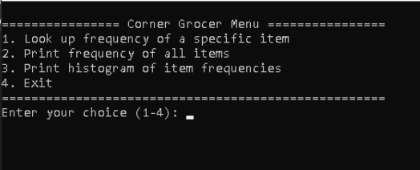
Program Startup: Menu Display
The Corner Grocer program displays the main menu after launching.
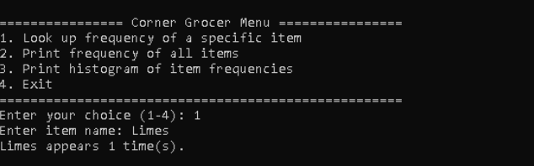
Option 1: Searching for an item
Searches for a specific item using menu option 1.

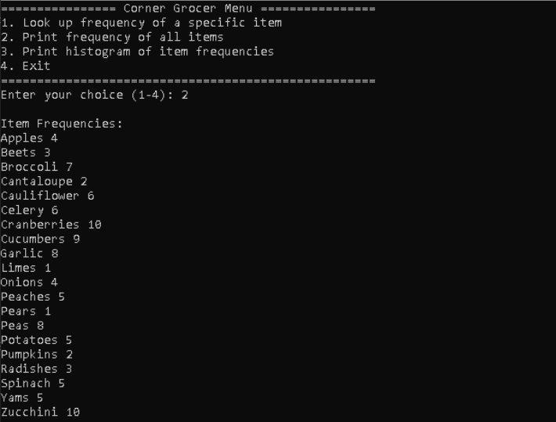
Option 2: List of all items with frequencies
Displays item frequencies based on the input file.

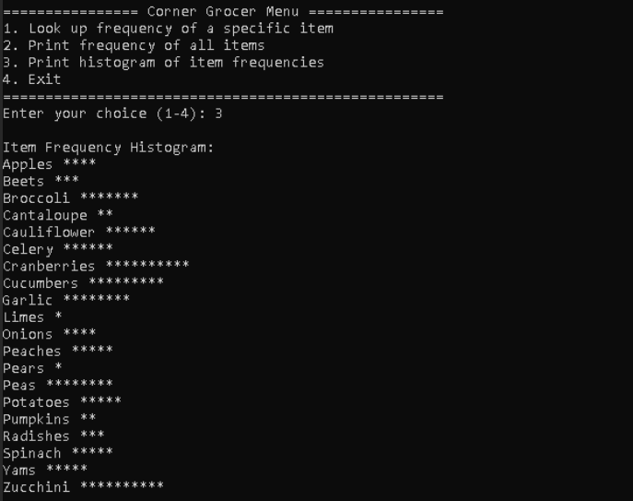
Option 3: Histogram using asterisks
Histogram view of item frequencies when choosing option 3.
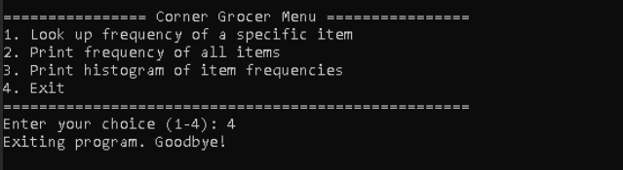
Option 4: Exit Program

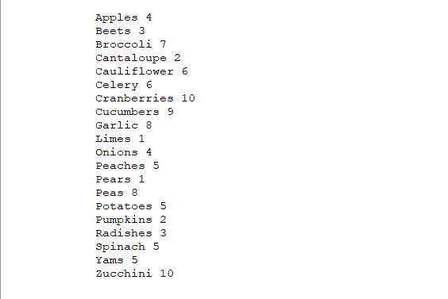
Frequency.dat File

